Online Municipal Job Opportunities



A Project Presented To

To Faculty of The Computer Department

College of Arts and Sciences

Iloilo Science and Technology University

La Paz, Iloilo City



In Partial Fulfillment

Of the Requirements for the Degree

Bachelor of Science in Information Technology



Erica Mae Molina

Christopher Ross B. Erebaren

Mary Del M. Consabo

Jemarie B. Peregrino

**CHAPTER I**

**INTRODUCTION**

**Background of the study**

People are struggling to find a job, especially the fresh graduates. The Public Employment Service Office (PESO) in Oton, Iloilo is helping those job seekers who submitted their job application in their office. They were able to help and refer them to a company that suits their qualifications. The employer / company also passed their company business requirements to PESO so that they can find some prospective individuals / professionals who can help their business grow.

Currently the whole world is facing a pandemic and most events, especially face to face submission of application, are prohibited in order to reduce the transmission of the virus. So, the PESO is having problems gathering some applications to both the applicant and employer because the applicant will submit their job application into their office and also the employer will submit their company business requirements into their office. There will be face to face submission but the face-to-face submission is prohibited. They needed a system to be managed online so that all the processes will be easily done.

For this concern, the researchers develop an Online Municipal Job Opportunities which will help to solve the problem of PESO, the employer, and the applicant. The system is a website where anyone can search into the internet. The PESO will manage all the applications online so that there will be no more face-to-face submission of applications. It can also help the employer because they can post job vacancies into the system for the interested applicant who wishes to apply in their company.

It can also help applicants because they can search for job hiring, and be able to submit their resume directly to the company they wanted to apply for.

These can be a great help for all because it will make the process easy and convenient.

**Objectives of the Study**

This study aims to design and develop an Online Municipal Job Opportunities and evaluate based on ISO 25010

Specifically, this study aims to:

1. To design and develop an Online Municipal Job Opportunities that will able to:

* Register users
* Manage account
* Manage employer applications
* Manage jobs
* Applicant can apply a for jobs
* Send notification

1. Evaluate the system based on the international organization for standardization (ISO) 25010 eight (8) software quality standards namely Functional Suitability, Performance Efficiency, Comparability, Usability, Reliability, Security, Maintainability, and Portability.

**Conceptual Framework**

INPUT

PROCESS

OUTPUT

Register users

User information

Manage account

Account information

Manage employer application

Employer application information

Online Municipal Job Opportunities

Manage jobs

Job information

Applicant can apply a for jobs

Send notification

Applicant

information

System Evaluation based on ISO 25010

**Figure 1.0 Conceptual Framework of Online Municipal Job Opportunities**

The input, process, and output of the Online Municipal Job Opportunities is shown above. The PESO has full control of the system. The users will register their account into the system. The employer will register their account by entering their user account information which includes first name, middle name, last name, company name, user type, email address, and password. Also, the applicant will register their user account by entering their user information which includes their first name, middle name, last name, user type, email address, and password. All the users will use their email address and password to login into the system.

Once logged in, the employer will manage their personal account by updating their account information which includes company description, company address, date of establishment, and company logo. Also, the applicant will manage their personal account by updating their account information which includes date of birth, gender, contact number, address, religion, civil status, height, and profile picture. The applicant will also update their skill sets, work experience, and educational background.

Before being allowed to post job vacancies, the employer will be required to submit the company permits to PESO for review and approval. The system will then send notification to the PESO which includes the employer's company permits and date of submission. Once approved the employer can now post job vacancies which include their job title, job description, job responsibility, job qualification, industry, job type, number of vacancies, and monthly salary. The employer can now accept submitted resumes from the applicant who applied for their job vacancy. They will be notified once the applicant submitted their resume.

If the employer has posted a job the applicant can now search and apply for a job. The applicant will submit their resume to the company who they wish to apply for. The system will then send a notification to the employer which includes the applicant’s resume and date posted for the employer to review the application. Once the employer chooses an applicant, they will send a notification back to the applicant which includes the date of interview or exam.

The Online Municipal Job Opportunities can be used at any time with the use of their gadgets.

**Definition of Terms**

**User -** a person who uses or operates something, especially a computer or other machine. (Dictionary.com, 2021)

**Profile -** a short article giving a description of a person or organization. (Dictionary.com, 2021)

**Jobs -** A paid position of regular employment. (Dictionary.com, 2021)

**Requirement -** a thing that is needed or wanted. (Dictionary.com, 2021)

**Search -** try to find something by looking or otherwise seeking carefully and thoroughly. (Dictionary.com, 2021)

**Apply -** make a formal application or request. (Dictionary.com, 2021)

**Resume -** A resume is a formal document that a job applicant creates to itemize his or her qualifications for a position. A resume is usually accompanied by a customized cover letter in which the applicant expresses an interest in a specific job or company and draws attention to the most relevant specifics on the resume. (investpedia.com, 2021)

**Interview -** an oral examination of an applicant for a job, college admission, etc. (Dictionary.com, 2021)

**Notifications -** the action of notifying someone or something. (Dictionary.com, 2021)

**Significance of the Study**

The main beneficiaries of the Online Municipal Job Opportunities are the following:

**Public Employment Service Office (PESO) -** It will easy and convenient for the PESO to manage all the applications through the use of the system

**Employer -** The employer will no longer go to the PESO office to submit the requirements instead they will rather submit it through the use of the system. Also, can post job vacancies.

**Applicant –** The applicant will no longer go to the PESO office to submit their job application. Instead, they will rather search for a job and submit their job application to their desired company through the use of the system.

**Future Researchers –** The future researchers can use the system as one of the references for their study.

**Scope and Limitation**

This study, Online Municipal Job Opportunities will be implemented at the Public Employment Service Office (PESO). The coverage of this study is at Oton, Iloilo. The system is for local use only and not for international use. It focuses only on managing employer requirement applications, job posting, job searches, and job applications. The employer and applicant register their own account.

The employer will submit all the needed requirements for the PESO to be reviewed for approval. When the employer status is approved, they can now post job vacancies for them to be able to accept job applications from the interested applicant and send a notification which will include the applicant's interview and exam schedules.

The applicant can now search for a job position which they are interested in. They will be able to submit their resume directly to the company they are interested in. The Online Municipal Job Opportunities can be used at any employer and applicants that demand a quickest and easiest way to process applications. In selecting respondents, the researchers will use a purposive sampling technique for evaluating and testing the system. Purposive sampling techniques include participants who are selected based on the particular purpose of study and knowledge of participants. This

study was evaluated based on International Organization for Standardization (ISO) 25010 eight (8) software quality standards namely Functional Suitability, Performance Efficiency, Compatibility, Usability, Reliability, Security, Maintainability, and Portability

**CHAPTER II**

**REVIEW OF RELATED LITERATURE**

This chapter contains the related literature and studies relevant to the present study. It consists of information and methods which were used and implemented to the present system.

**Online Job Portal**

A job portal, also known as a career portal, is a modern name for an online job board that helps applicants find jobs and aids employers in their quest to locate ideal candidates. Career websites, such as Monster, Indeed and Simply Hired, have job portals that offer a broad range of jobs in a vast number of fields. Some government agencies, nonprofit organizations, universities and private businesses have their own job portals that applicants can access on the organization's website.

The relation of online job portal for this study is having the same concept when an employer wishes to post their job vacancies online and the applicants can search for a job and will apply for their desired job positions.

**Career Fairs**

(also known as jobs fairs or recruitment fairs) are a useful resource for candidates to use to find out about potential employers. They are typically organized in a large hall where potential employers will set up booths with members from their human resources (HR) team along with new employees, to tell those attending their company, their application process and anything else they might want to know.

Those attending a careers fair will be free to ask any questions they wish to prospective employers and take notes on their answer, as well as being able to take any promotional material or freebies that are offered by the firm. In addition, there will usually be talks held by either company attending or the organizer of the fair itself - often on a range of topics such as how to apply and acquire certain jobs.

The relation of the career fair for this study is like having a career fair but doing it online to reduce the face-to-face process due to the pandemic.

**Company Profile**

A company profile is actually a summary of all the relevant elements of an entity. It is in the form of a statement that describes important information about the business. A company profile is a marketing material that serves several purposes.

A company profile is created for potential customers, stakeholders, suppliers, financial institutions, government regulators and potential investors. The information in the company profile can vary in detail as it is dependent on the person or institution it is made for. A concise profile is often posted by most of the organizations on their websites so that interested parties can make a brief assumption from the given disclosure.

The relation of the company profile for this study is a company / employer can manage their profile into the system to be able to show and search when a user visits the website.

**ISO/IEC 25010 Software Engineering**

**Quality Model**

The quality model was the cornerstone of a product quality evaluation system. It determines which quality characteristics will be taken into account when evaluating the properties of a software product. The quality of a system is the degree to which the system satisfies the stated and implied needs of its various stakeholders, and thus provides value. Those stakeholders' needs are precisely what was represented in the quality model, which categorizes the product quality into characteristics.

**Functional Suitability** - This characteristic represents the degree to which a product or system provides functions that meet stated and implied needs when used under specified conditions. This characteristic was composed of sub-characteristics, the functional completeness in which a set of functions covers all the specified tasks and user objectives. The functional correctness in which a product or system provides the correct results with the needed degree of precision. And the functional appropriateness in which the functions facilitate the accomplishment of specified tasks and objectives.

**Performance Efficiency** - This characteristic represents the performance relative to the

number of resources used under stated conditions. This characteristic was composed of sub- characteristics, the time behavior in which the response and processing times and throughput rates of a product or system, when performing its functions, meet requirements. The resource utilization in which the amounts and types of resources used by a product or system, when performing its functions, meet requirements. And the capacity in which the maximum limits of a product or system parameter meet requirements.

**Compatibility** - Degree to which a product, system or component can exchange information with other products, systems or components, and/or perform its required functions, while sharing the same hardware or software environment. This characteristic was composed of sub-characteristics, the co-existence in which a product can perform its required functions efficiently while sharing a common environment and resources with other products, without detrimental impact on any other product. And the Interoperability in which two or more systems, products or components can exchange information and use the information that has been exchanged.

**Usability** - Degree to which a product or system can be used by specified users to achieve specific goals with effectiveness, efficiency and satisfaction in a specified context of use. This characteristic was composed of sub-characteristics, the appropriate recognizability in which users can recognize whether a product or system is appropriate for their needs. The learnability in which a product or system can be used by specified users to achieve specific goals of learning to use the product or system with effectiveness, efficiency, freedom from risk and satisfaction in a specified context of use.

The operability in which a product or system has attributes that make it easy to operate and control. The User error protection in which a system protects users against making errors. The User interface aesthetics in which a user interface enables pleasing and satisfying interaction for the user. And the Accessibility in which a product or system can be used by people with the widest range of characteristics and capabilities to achieve a specified goal in a specified context of use.

**Reliability** - Degree to which a system, product or component performs specific functions under specified conditions for a specified period of time. This characteristic was composed of sub-characteristics, the maturity in which a system, product or component meets needs for reliability under normal operation. The availability in which a system, product or component is operational and accessible when required for use. The fault tolerance in which a system, product or component operates as intended despite the presence of hardware or software faults. And the recoverability in which in the event of an interruption or a failure, a product or system can recover the data directly affected and re-establish the desired state of the system.

**Security** - Degree to which a product or system protects information and data so that persons or other products or systems have the degree of data access appropriate to their types and levels of authorization. This characteristic was composed of sub-characteristics, the confidentiality in which a product or system ensures that data are accessible only to those authorized to have access. The integrity in which a system, product or component prevents unauthorized access to, or modification of, computer programs or data. The non-repudiation in which actions or events can be proven to have taken place, so that the

events or actions cannot be repudiated later. The accountability in which the actions of an entity can be traced uniquely to the entity. And authenticity in which the identity of a subject or resource can be proved to be the one claimed.

**Maintainability** - This characteristic represents the degree of effectiveness and efficiency with which a product or system can be modified to improve it, correct it or adapt it to changes in the environment, and in requirements. This characteristic was composed of sub-characteristics, the modularity in which a system or computer program is composed of discrete components such that a change to one component has minimal impact on other components. The reusability in which an asset can be used in more than one system, or in building other assets. The analyzability in which degree of effectiveness and efficiency with which it is possible to assess the impact on a product or system of an intended change to one or more of its parts, or to diagnose a product for deficiencies or causes of failures, or to identify parts to be modified. The modifiability in which a product or system can be effectively and efficiently modified without introducing defects or degrading existing product quality. And testability in which degree of effectiveness and efficiency with which test criteria can be established for a system, product or component and tests can be performed to determine whether those criteria have been met.

**Portability** - Degree of effectiveness and efficiency with which a system, product or component can be transferred from one hardware, software or other operational or usage environment to another. This characteristic was composed of sub-characteristics, the adaptability in which a product or system can effectively and efficiently be adapted for different or evolving hardware, software or other operational or usage environments. The

install ability in which the degree of effectiveness and efficiency with which a product or system can be successfully installed and/or uninstalled in a specified environment. And the replacement in which a product can replace another specified software product for the same purpose in the same environment.

**CHAPTER III**

**METHODOLOGY**

This chapter consists of a system development process, requirements analysis, graphical user interface, design specification, testing and operation, and project evaluation. In further study, research and understanding of the system must be considered in order to come up with a good project and design.

**Project Description**

Online Municipal Job Opportunities is a web-based system wherein both the PESO, employer, and applicant are the users and can login and logout into the system. The PESO has the full control of the system. The employer will register a new account by entering their user information. Then the employer will submit their company permits to the PESO for review and approval. The system will then send notification to the PESO which includes the employer's company permits and date of submission. If the employer is approved then they are able to post job vacancies. The applicant can now search for a job but if they want to submit their resume to their desired company they must register first if they don't have an account yet. After the applicant has been registered, they can now submit their resume directly to the company they have chosen. The system will then send a notification to the employer which includes the applicant’s resume and date posted for the employer to review the application. Once the employer chooses an applicant, they will send a notification back to the applicant which includes the date of interview or exam.

**Development Process**

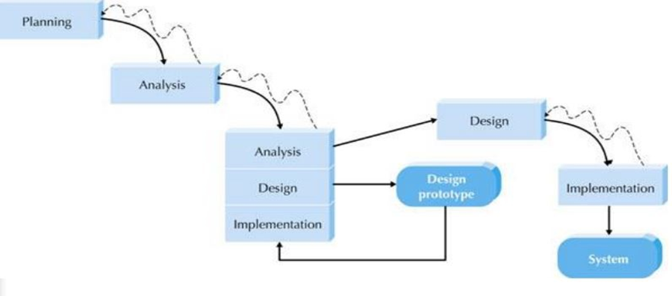

**Figure 2.0 Throw-away Prototyping Methodology**

The Throw-away Prototyping methodology gave the researchers the advantage of refining key issues before the system is built, hence a more stable and reliable system is produced.

Throw-away prototyping has a relatively thorough analysis phase that was used to

gather information and develop ideas for the system concept. A design prototype will be used to gain feedback from the end-user. Each issue was examined by analyzing, designing, and building a design prototype. If the current phase is completed, that is when the development proceeded to the next phase. It also gave the researchers a chance or option to go back to the previous phases when few revisions were needed.

The design prototype is not a working system. When the project moved to the design and implementation phase, the design prototype was thrown away.

**Planning.** During this phase, the researchers conducted a study in the Public Employment Service Office, identified the problem and conducted a preliminary investigation and interview to gather information and data needed. The researchers also determine the feasibility and how it would be developed by understanding the environment. The researchers used to gather data related to the system and additional details to support the system project.

**Analysis.** In this phase, the researcher**s** undergo research in some current system that was likely related to the features of the system to be developedwith the use of gathered data and additional details, a careful study and elaboration of ideas of every member of the group about the system project was done. Ideas such as what the researchers are going to do, how will the information gathered affect the flow of the project, and how the information is related to each other were relayed in order to identify the different angles that may lead to system problems.

**Design.** In this phase, the researchers decided how the system would operate in

terms of hardware software and network infrastructure, and files that would be needed. The researchers also gathered feedback from the company. After the company conformed to the requirements, the researchers came up with the idea of building the system. This is where the system was built or created. It shows how the system looked and how it functioned.

**Implementation.** The researchers developed the construction of the final system. The researchers activated the system to be used by the users and will be the basis of their feedback. And the team used the feedback contributed by the users to enhance or make changes to the system.

**Requirement Analysis**

Research, observations, and interviews were used as techniques in the gathering of requirements in order to create the system. Based on this, the researchers were able to identify the functional and non-functional requirements of the system. The researchers created different diagrams, with the use of Unified Modelling Language (UML), which include activity diagram, use-case diagram, class diagram, sequence diagram, and deployment diagram.

**Use Case Diagram**

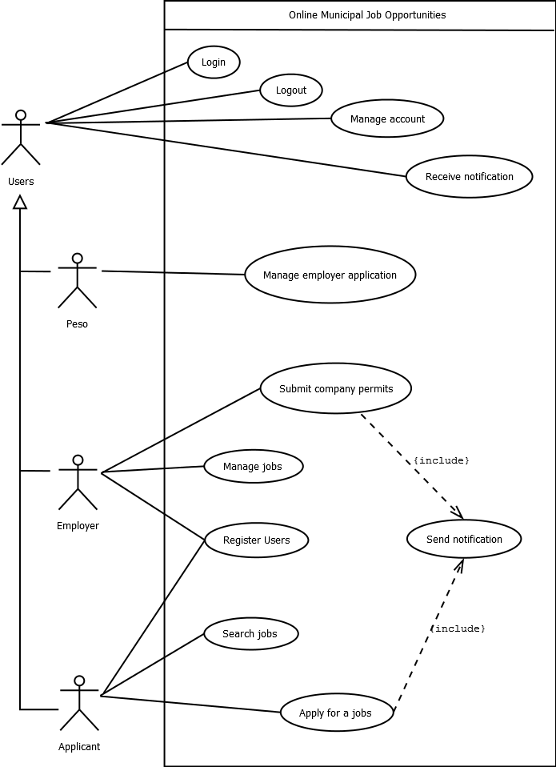

**Figure 3.0 Use Case Diagram for Online Municipal Job Opportunities**

The use-case diagram for Online Municipal Job Opportunities as shown in figure 3.0. The actors of Online Municipal Job Opportunities are the PESO, employer, and the applicant. The users can login, manage accounts, receive notification, and logout from the system. The PESO will manage employer applications which can also manage the employer status if they are allowed to post a job vacancy if the employer submitted all the required company permits to the PESO. The employer will register a new account to be able to submit the company permits to PESO for review and approval. If the employer status was approved, then they can now post job vacancies. The applicant can now search for a job but if the applicant wants to submit their resume they must register first if they don’t have an account yet. Then the applicant will be able to submit their resume directly to the employer. The system will then notify the employer which includes the resume of the applicant for review.

**Activity Diagram**

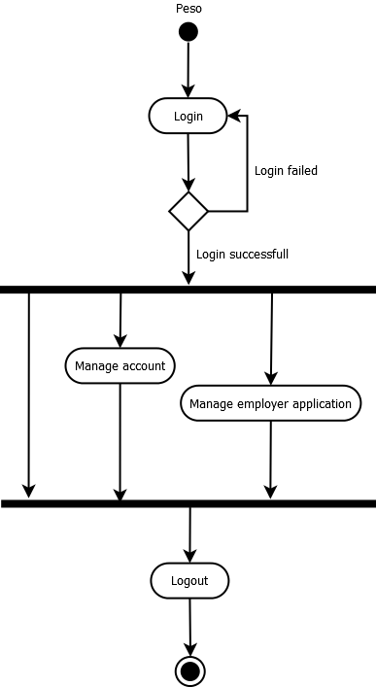

**Figure 4.0 Activity Diagram for Peso**

As shown in figure 4.0 illustrates the activity diagram of PESO of Online Municipal Job Opportunities. In logging in of the PESO, the PESO will enter their email address and password to login into the system. The system will verify the PESO account. If the PESO entered a wrong account details, then it will return back to the login until the PESO enters their correct account details. When logged in, the PESO can manage an account, and manage the employer application which includes the employer's submitted company permits and the employer’s status for allowing to post job vacancies. After all the processes, the PESO can log out from the system.

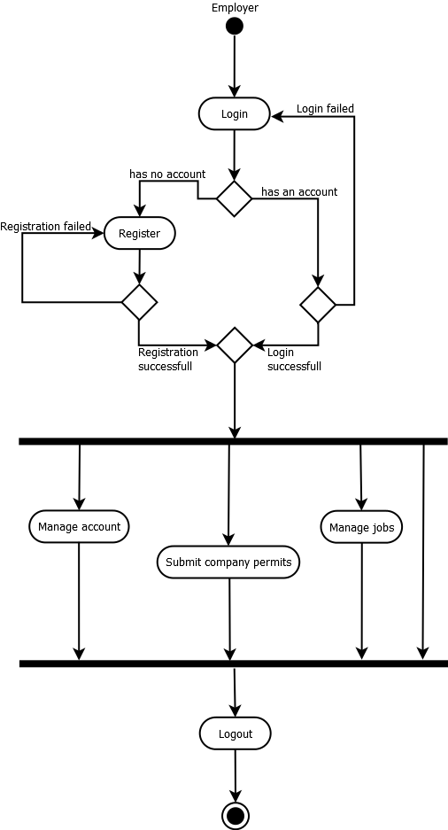

**Figure 5.0 Activity Diagram for Employer**

As shown in figure 5.0 illustrates the activity diagram of Employer of Online Municipal Job Opportunities. If the employer has no account. The employer must register first but if the employer has an account. The employer will enter their email address and password to login into the system. The system will verify the employer account. If the employer enters the wrong account details, then it will return back to the login until the employer enters their correct account details. When logged in, the employer can manage an account, submit company permits to PESO for review and approval, and once the employer is approved, they can now manage jobs. After all the processes, the employer can log out from the system.

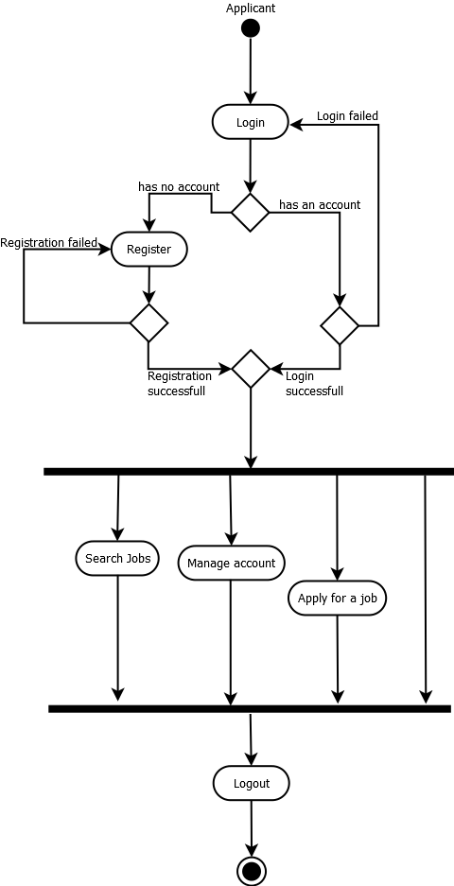

**Figure 6.0 Activity Diagram for Applicant**

As shown in figure 6.0 illustrates the activity diagram of Applicant of Online Municipal Job Opportunities. In logging in of the applicant, if the applicant has no account. The applicant must register first but if the applicant has an account. The applicant will enter their email address and password to login into the system. The system will verify the applicant account. If the applicant enters the wrong account details, then it will return back to the login until the applicant enters their correct account details. When logged in, the applicant can search jobs, manage an account, and apply for a job. After all the processes, the applicant can log out from the system.

**Class Diagram**

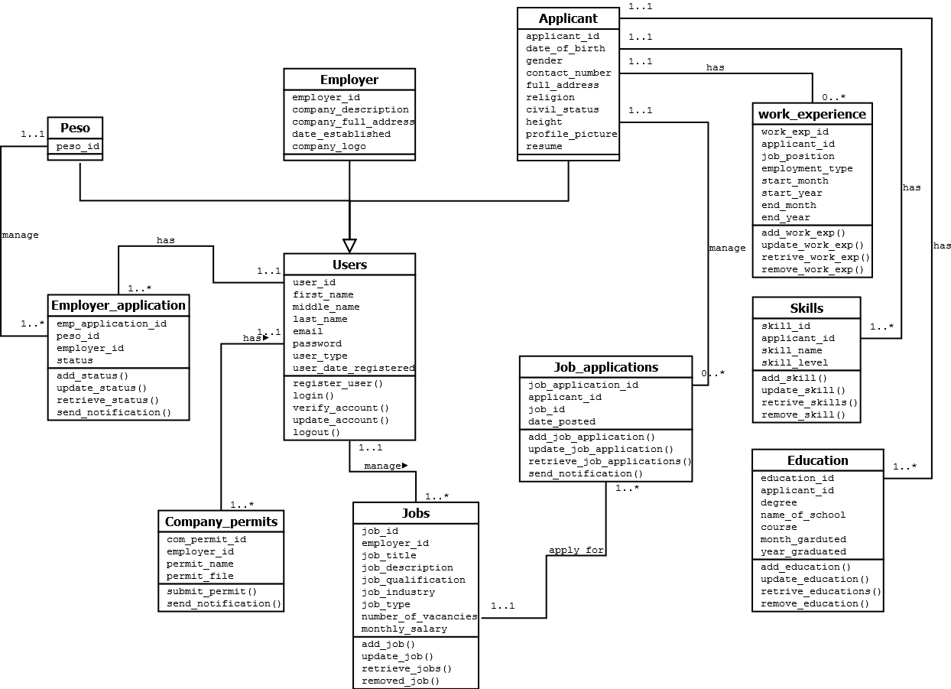

**Figure 7.0 Class Diagram for Online Municipal Job Opportunities**

**Sequence Diagram**

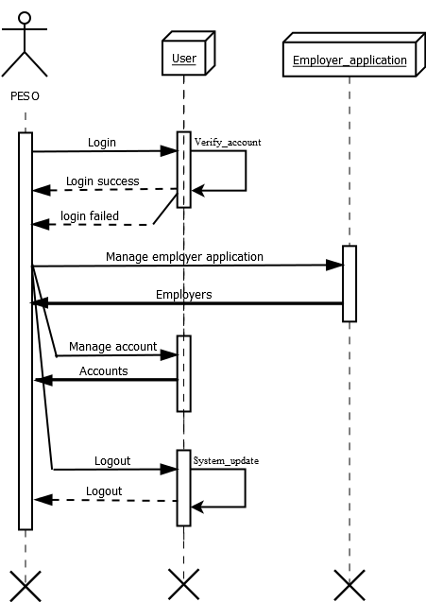

**Figure 8.0 Sequence Diagram for Peso**

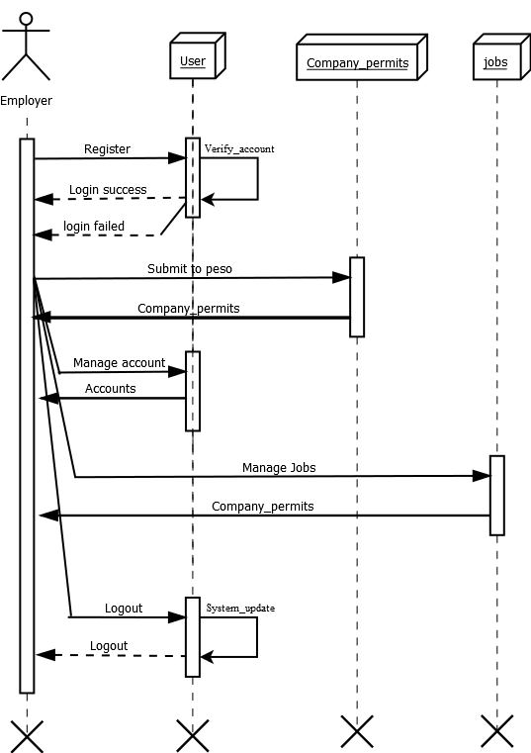

**Figure 9.0 Sequence Diagram for Employer**

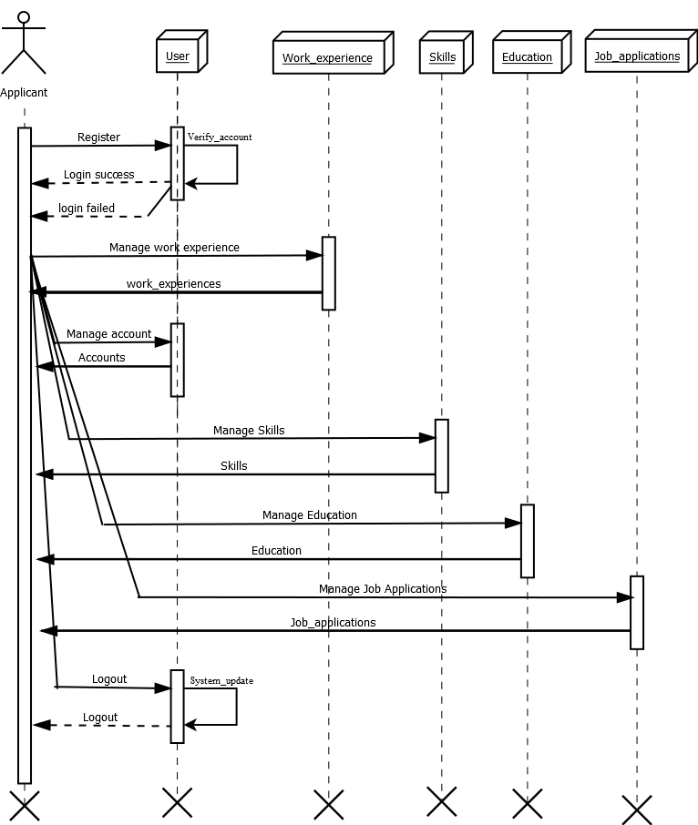

**Figure 10.0 Sequence Diagram for Applicant**

**Graphical User Interface**

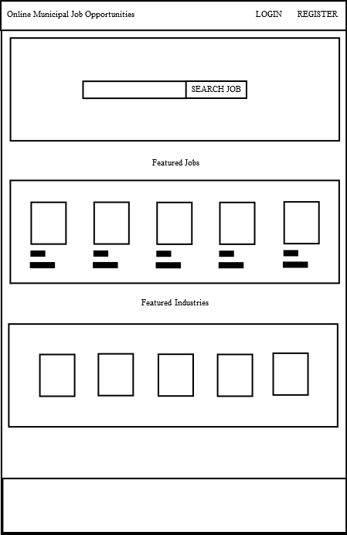

**Figure 11.0 Homepage**

The homepage or the first page when a user visits the website’s URL. The user can see the company name, logo, login, and register button on the header navigation menu. the search input to search a job, the featured jobs, the featured industries, and the footer in the bottom.

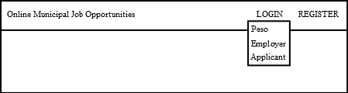

**Figure 11.1 Navigation Menu Click on Login button**

The navigation menu. When the user clicks on the login button it will display a dropdown option for which account to login (peso, employer, or applicant).

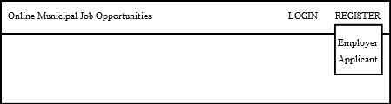

**Figure 11.2 Navigation Menu Click on Register button**

The navigation menu. When the user clicks on the register button it will display a dropdown option for which account to register (employer, or applicant).

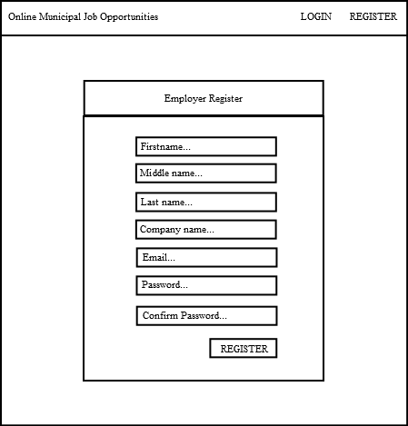

**Figure 11.3 Employer Register Page**

The employer registers the page. When the user clicks on the employer register button it will redirect to the page shown above where the employer will enter the needed information in order to create a new account and access into the system.

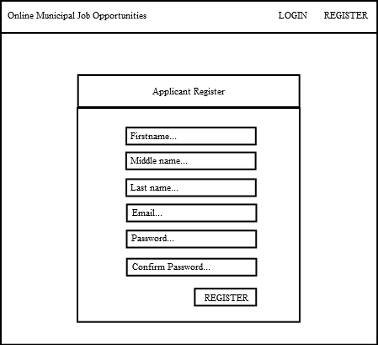

**Figure 11.4 Applicant Register Page**

The applicant register page. When the user clicks on the applicant register button it will redirect to the page shown above where the applicant will enter the needed information in order to create a new account and access into the system.

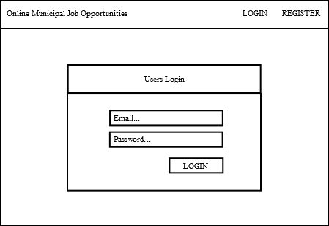

**Figure 11.5 Users Login Page**

The user’s login page. The users will enter their valid email and password in order to access the system.

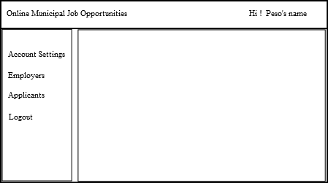

**Figure 11.6 Peso Dashboard Page**

The peso will be directed to the peso dashboard page after they entered their valid email and password into the login form.

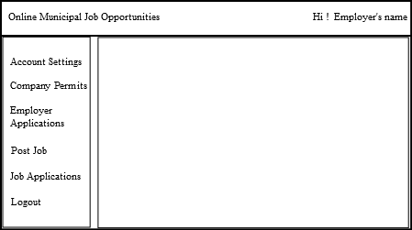

**Figure 11.7 Employer Dashboard Page**

The employer will be directed to the employer dashboard page after they entered their valid email and password into the login form.

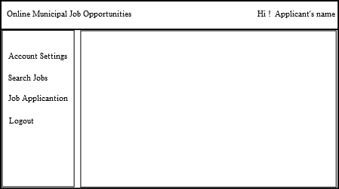

**Figure 11.8 Applicant Dashboard Page**

The employer will be directed to the employer dashboard page after they entered their valid email and password into the login form.

**Deployment Diagram**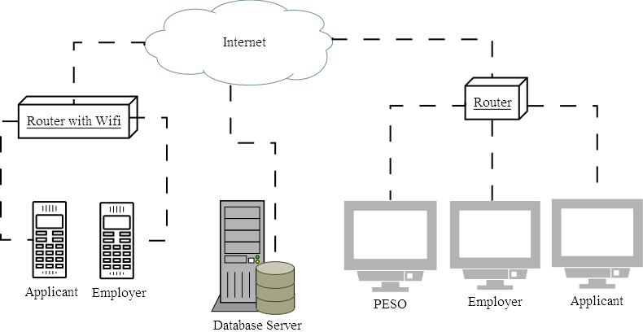

**Figure Deployment Diagram for Online Municipal Job Opportunities**

As shown in figure 11.0 illustrates the deployment diagram of Online Municipal Job Opportunities. The figure shows that the users must have a router if they are using a personal computer in order to connect to the internet. If they are using a mobile phone, they must connect to a router with Wi-Fi in order to connect to the internet.

**Testing and Operation**

White box testing and black box testing are both important in the development of a system. White box testing is a method of testing software that tests internal structures or the working of an application. The internal perspectives of the system are used to design test cases. The tester chooses inputs to exercise paths through the code and determine the appropriate outputs. This kind of testing will help the researchers in developing their system and to prevent any errors from occurring in the system.

While, black box testing is a software testing method that allows the developers to examine the functionality of a system. These tests can be functional or non-functional, though usually functional. It is an approach that will likely remove different kinds of bugs or errors in the Online Municipal Job Opportunities. This method is named so because the software program, in the eyes of the tester, is likely a block box; inside which one cannot see.

**Project Evaluation**

The criteria for the project evaluation of the system are based on the standards of the International Organization for Standardization (ISO) 25010. The ISO 25010 software quality model identifies eight major quality characteristics, specifically, Functional Suitability, Performance Efficiency, Compatibility, Usability, Reliability, Security,

Maintainability, and Portability.

The researcher used one of the sampling methods. The non-probability sampling as sampling type was used to identify who tested the system, Online Municipal Job Opportunities. The type of non-probability sampling used was convenience sampling and the researcher selected one admin and one agent who acted as the respondents. Convenience sampling is a quick method to use since the decision of the respondents to be included in the sample is done during the researcher’s convenient time.

Likertz scale is the statistical tool used for the evaluation which employs questionnaires and is the most used approach to scaling responses in research. The range captures the intensity of the respondents’ judgment for a given item while the results of analysis of multiple items reveals a pattern that has scaled properties of the kind Likert identified. A Likertz is a statement which the respondent is asked to evaluate according to any kind of subjective or objective criteria

**Table 1.0 Criteria for Evaluation**

|  |  |
| --- | --- |
| **Mean Scale** | **Interpretation** |
| 4.04 – 4.84 | Excellent |
| 3.23 – 4.03 | Very Good |
| 2.42 – 3.22 | Good |
| 1.61 – 2.41 | Fair |
| 0.80 – 1.60 | Poor |

Displayed in table 1.0 is the rating scale for the system evaluation using Likertz scale. If the score is between 0.80 – 1.60 it is interpreted as “Poor”, if the score is between 1.61 – 2.41 it is interpreted as “Fair”, score is between 2.42 – 3.22 it is interpreted as “Good”, score is between 3.23 – 4.03it is interpreted as “Very Good”, score is between 4.04 – 4.84 it is interpreted as “Excellent”.

**REFERENCES**

Online job portal “Definition of Online job portal”, retrieved from <https://careertrend.com/facts-6883857-definition-job-portals.html>, retrieved on May 27, 2021

Job Fairs “Definition of Job Fairs”, retrieve from <https://www.wikijob.co.uk/content/application-advice/job-applications/careers-fair>, retrieved on May 27, 2021

Company profile “Definition of Company profile”, retrieve from <https://www.marketing91.com/what-is-company-profile/>

retrieved on May 27, 2021